**THIẾT KẾ BỘ ĐẾM BCD 5BIT UP/DOWN**

1. Thiết kế mạch cộng-trừ HAS:

*Truth table:

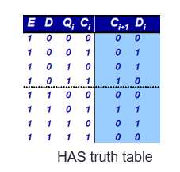

* C (next) = CD’Q + CDQ’
* D (Qnext) = C XOR Q

-Schematic:

-Đóng gói:

** Thiết kế bộ đếm:

-Operator table:

-Schematic 5bit counter:

-Đóng gói:

*Thiết kế mux21_5bit (Sử dụng mux2_1):

-schematic:

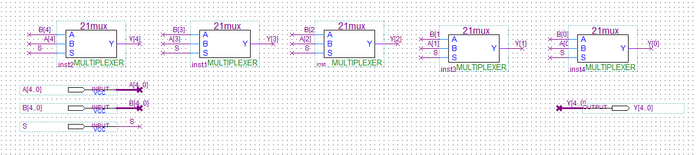

-Đóng gói:

**Thiết kế bộ nạp:

-Truth table:

|  |  |  |  |  |  |
| --- | --- | --- | --- | --- | --- |
| D | Q[3] | Q[2] | Q[1] | Q[0] | LOAD |
| 0 | 0 | 0 | 0 | 0 | 1 |
| 1 | 1 | 0 | 0 | 1 | 1 |

*Schematic:

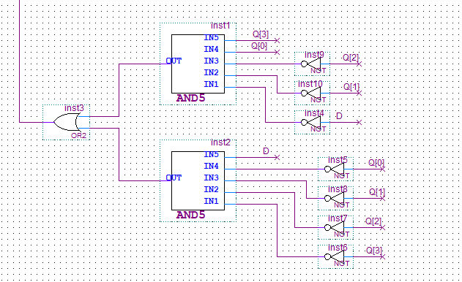

*Tổng hợp mạch:

-Schematic BCD5bit:

-Đóng gói:

**Kết quả chạy mô phỏng: